

ACKNOWLEDGEMENT
I would like to express my sincere gratitude to everyone who supported and encouraged me during this project.
This project, “Smart Manufacturing Analytics and Workforce Productivity Analysis in the Apparel Industry,” was completed as a self-learning project to improve my skills in data analysis, business analytics, and manufacturing performance optimization.
I would also like to thank the online learning resources, tutorials, and datasets that helped me understand the concepts related to smart manufacturing, workforce productivity, and data-driven decision-making.
This project helped me develop practical knowledge in Excel, Python, Power BI, and analytical thinking.

ABSTRACT
This project focuses on analyzing workforce productivity and operational efficiency in the apparel manufacturing industry using statistical analysis, machine learning, and business intelligence techniques. Publicly available garment manufacturing datasets were used for the analysis.

Descriptive statistics, correlation analysis, regression analysis, ANOVA, and machine learning algorithms were applied using SPSS and Python. Power BI dashboards were developed to visualize workforce performance and productivity trends.

The findings revealed significant relationships between targeted productivity, incentives, idle time, and actual productivity. The developed analytics system supports data-driven decision-making and operational improvement within manufacturing environments.

Table of Contents
LIST OF TABLES 5
LIST OF FIGURES 5
1.INTRODUCTION 6
1.1 Background of the Study 6
1.2 Problem Statement 6
1.3 Research Objectives 7
1.4 Research Questions 7
1.5 Significance of the Study 7
2.LITERATURE REVIEW 8
2.1 Introduction 8
2.4 Manufacturing Analytics 9
2.5 Statistical Analysis in Manufacturing Research 9
3.METHODOLOGY 10
3.1 Dataset Description 10
3.3 Software Tools 11
3.4 Statistical Methods 12
3.5 Machine Learning Methods 12
3.6 Productivity Prediction and Optimization Approach 12
4.EXPLORATORY DATA ANALYSIS(EDA) 13
4.1 Department-wise Productivity Analysis 13
4.2 Productivity Analysis by Working Day 14
4.3 Overtime Analysis by Department 14
4.4 Incentive Analysis by Department 15
4.5 Idle Time Analysis by Department 15
5.STATISTICAL ANALYSIS 16
5.1 Descriptive Statistics 16
5.2 Correlation Analysis 16
5.3 Regression Analysis 17
5.4 ANOVA 18
6.MACHINE LEARNING & PRODUCTIVITY OPTIMIZATION 20
6.1 Productivity Prediction Model 20
6.2 Productivity Optimization Scenario Analysis 22
Scenario 1: Increase Targeted Productivity 22
Scenario 2: Optimize Workforce Allocation 22
Scenario 3: Improve Overtime Management 22
Scenario 4: Enhance Incentive Programs 22
Scenario 5: Reduce Idle Time 22
7.POWER BI DASHBOARD 24
8.FINDINGS AND RECOMMENDATIONS 25
8.1 Findings 25
8.2 Recommendations 26
9.CONCLUSION 27

LIST OF TABLES

Table 1: Software Tools Used in the Study 11
Table 2: Descriptive Statistics 16
Table 3: Correlation Matrix 16
Table 4: Model Summary & ANOVA Table for Regression Model 17
Table 5: Regression Coefficients 17
Table 6: Descriptive Statistics by Working Day & Test of Homogeneity of Variances 18
Table 7: One-Way ANOVA Results 19

LIST OF FIGURES

Figure 1: Dataset Before Missing Value Handling 10
Figure 2: Dataset After Missing Value Handling 10
Figure 3: Dataset Duplicate Value Handling 11
Figure 4: Data Type Verification of Dataset Variables 11
Figure 5: Average Productivity by Department 13
Figure 6: Average Actual Productivity and Targeted Productivity by Working Day 14
Figure 7: Total Overtime by Department 14
Figure 8: Average Incentive by Department 15
Figure 9: Average Idle Time by Department 15
Figure 10: Random Forest Model Performance Results 20
Figure 11: Actual vs Predicted Productivity 20
Figure 12: Feature Importance of Workforce Productivity Factors 21
Figure 13: Productivity Optimization Framework 23
Figure 14: Workforce Productivity Analytics Dashboard Home Page 24
Figure 15: Workforce Productivity Analytics Dashboard 24

1.INTRODUCTION

Background of the Study
The apparel manufacturing industry is one of the most important sectors contributing to economic growth and employment opportunities in many countries. In Sri Lanka, the apparel industry plays a significant role in export earnings and provides employment to a large workforce. Due to increasing global competition, apparel manufacturers are continuously seeking ways to improve productivity, reduce operational inefficiencies, and enhance overall performance.
Workforce productivity is a key factor influencing the success of manufacturing organizations. Factors such as overtime, incentives, idle time, workforce allocation, and operational efficiency can significantly affect productivity levels. Therefore, organizations need effective methods to monitor and evaluate these factors to ensure optimal performance.
With the advancement of data analytics and business intelligence technologies, organizations are increasingly using data-driven approaches to support decision-making processes. Statistical analysis, predictive analytics, and data visualization techniques provide valuable insights that can help managers identify productivity issues and implement suitable improvement strategies.
This study focuses on analyzing workforce productivity within the apparel manufacturing industry using statistical and analytical techniques. By examining the relationships between various operational factors and productivity levels, the study aims to generate useful insights that can support performance improvement and managerial decision-making.

Problem Statement
Maintaining high productivity levels is a major challenge in apparel manufacturing environments. Workforce productivity can be influenced by several factors, including overtime, idle time, incentives, and workforce size. Although organizations collect large amounts of operational data, these data are often underutilized in identifying productivity-related issues and supporting decision-making processes.
Traditional methods of monitoring productivity may not effectively reveal hidden patterns and relationships among operational variables. As a result, organizations may face difficulties in identifying the key factors affecting workforce performance and implementing appropriate improvement strategies.
Therefore, there is a need for a data-driven analytical approach that can evaluate workforce productivity, identify significant influencing factors, and provide insights for improving operational efficiency in apparel manufacturing environments.

Research Objectives
Main Objective
To develop a smart manufacturing analytics framework for analyzing workforce productivity and operational efficiency in the apparel manufacturing industry using statistical and analytical techniques.
Specific Objectives
- To analyze workforce productivity and operational performance in apparel manufacturing environments.
- To identify the factors affecting workforce productivity using statistical analysis techniques.
- To examine the relationships between overtime, incentives, idle time, workforce size, and actual productivity.
- To compare productivity performance across departments, teams, and working days.
- To develop productivity prediction and optimization strategies using machine learning techniques.
- To develop an interactive business intelligence dashboard for supporting managerial decision-making.

Research Questions
The study seeks to answer the following research questions:
- What factors significantly influence workforce productivity in apparel manufacturing environments?
- How do overtime and idle time affect actual productivity levels?
- Is there a relationship between incentives and workforce productivity?
- Do productivity levels differ across different working days?
- How can data analytics, machine learning, and business intelligence tools support productivity improvement and decision-making?

Significance of the Study
This study demonstrates the application of statistical analysis and business analytics techniques to improve workforce productivity in manufacturing environments. The findings provide insights into factors affecting productivity and support data-driven decision-making. From an academic perspective, the study applies concepts from Industrial Statistics and Mathematical Finance, including statistical analysis, machine learning, and data visualization, while contributing to the understanding of workforce productivity within the apparel manufacturing industry.

2.LITERATURE REVIEW

2.1 Introduction
The manufacturing industry plays a significant role in economic development and employment generation worldwide. Among various manufacturing sectors, the apparel industry is highly labor-intensive and depends heavily on workforce productivity and operational efficiency. As global competition continues to increase, manufacturing organizations are focusing on improving productivity, reducing operational costs, and enhancing decision-making through data-driven approaches.
This chapter reviews previous studies related to workforce productivity, manufacturing analytics, statistical analysis, machine learning techniques, and business intelligence applications in manufacturing environments. The review provides the theoretical foundation for the current study and highlights the importance of applying analytical methods to improve operational performance.
2.2 Workforce Productivity in Manufacturing Industries
Workforce productivity refers to the efficiency with which employees convert inputs such as labor, time, and resources into outputs. Productivity is considered one of the most important indicators of organizational performance, particularly in labor-intensive industries such as apparel manufacturing.
According to previous studies, workforce productivity can be influenced by several factors including employee motivation, overtime work, incentives, working conditions, training, and workforce allocation. Organizations with higher productivity levels are generally able to achieve better operational performance, lower production costs, and improved competitiveness.
Researchers have found that effective productivity monitoring helps organizations identify inefficiencies and implement improvement strategies that enhance workforce performance and operational outcomes.
2.3 Factors Affecting Workforce Productivity
Several studies have identified key factors that influence workforce productivity within manufacturing environments.
Overtime - Overtime is commonly used in manufacturing organizations to meet production targets and customer demands. While moderate overtime may increase production output, excessive overtime can lead to worker fatigue, reduced efficiency, and lower productivity levels.
Incentives - Employee incentive programs are widely used to motivate workers and improve performance. Research findings suggest that financial and non-financial incentives can positively influence employee productivity and encourage higher levels of performance.
Idle Time - Idle time refers to periods during which employees or machines remain inactive due to operational disruptions, machine breakdowns, material shortages, or workflow inefficiencies. Studies indicate that increased idle time negatively affects productivity and overall manufacturing efficiency.
Workforce Size - The number of workers assigned to production activities can also influence productivity. Proper workforce allocation helps organizations balance workloads and improve operational performance.

2.4 Manufacturing Analytics
Manufacturing analytics refers to the use of data analysis techniques to improve manufacturing processes and operational decision-making. Modern manufacturing organizations collect large volumes of operational data that can be analyzed to identify trends, inefficiencies, and opportunities for improvement.
Manufacturing analytics enables organizations to:
- Monitor operational performance.
- Identify productivity bottlenecks.
- Improve resource utilization.
- Reduce operational costs.
- Support strategic decision-making.
The adoption of manufacturing analytics has increased significantly due to advances in data collection technologies and analytical software tools.

2.5 Statistical Analysis in Manufacturing Research
Statistical analysis plays an important role in manufacturing research by providing methods for understanding relationships between variables and evaluating organizational performance.
Descriptive Statistics - Descriptive statistics such as mean, median, standard deviation, minimum, and maximum values are commonly used to summarize manufacturing data and understand overall performance patterns.
Correlation Analysis - Correlation analysis helps researchers identify relationships between variables. In productivity studies, correlation analysis is often used to examine the relationships between productivity and factors such as overtime, incentives, and idle time.
Regression Analysis - Regression analysis is widely used to determine the impact of independent variables on a dependent variable. In workforce productivity research, regression models are frequently applied to identify factors that significantly influence productivity levels.
Analysis of Variance (ANOVA) - ANOVA is used to compare productivity levels across different groups or categories. In this study, ANOVA was applied to compare productivity across different working days. This technique helps researchers determine whether significant differences exist among groups.

3.METHODOLOGY

3.1 Dataset Description
This study utilized the Garment Worker Productivity Dataset obtained from the UCI Machine Learning Repository. The dataset contains operational and workforce-related information collected from a garment manufacturing environment and is widely used for productivity analysis and predictive modeling research.
The dataset consists of 1,197 observations and 15 variables representing different aspects of actual workforce productivity and manufacturing operations. Key variables include targeted productivity, productivity, overtime, incentives, idle time, idle workers, workforce size, department, team, and work-in-progress (WIP).
The dataset was selected because it provides relevant information for analyzing workforce productivity and operational performance within the apparel manufacturing industry.
Dataset Source - UCI Machine Learning Repository – Garment Worker Productivity Dataset.
3.2 Data Preprocessing
Before conducting statistical and analytical procedures, data preprocessing activities were performed to improve data quality and ensure reliable analytical results.
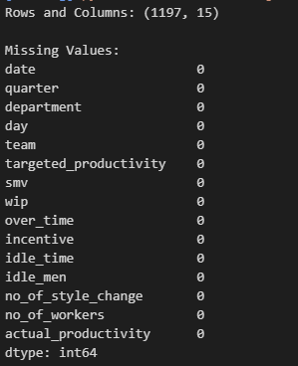
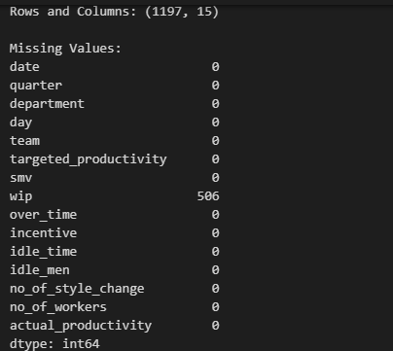
Missing Value Handling - The dataset was examined for missing values using Microsoft Excel and Python. Missing values identified in the WIP (Work in Progress) variable were handled using the mean imputation method, where missing observations were replaced with the average value of the corresponding variable.

Figure 1: Dataset After Missing Value Handling
Figure 2: Dataset Before Missing Value Handling

Duplicate Removal - The dataset was checked for duplicate records using Excel and Python. No significant duplicate records were identified within the dataset.

Figure 3: Dataset Duplicate Value Handling
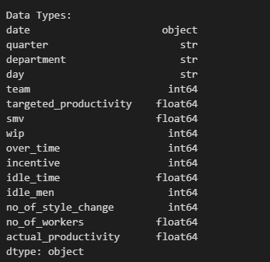
Data Formatting - Data formatting procedures were applied to ensure consistency among variables. Variable names, numerical formats, and data types were verified before conducting statistical analysis.

Figure 4: Data Type Verification of Dataset Variables
Data Normalization - To improve analytical performance and model accuracy, numerical variables were reviewed and prepared for subsequent statistical and machine learning analyses. No normalization was required because the Random Forest model is not sensitive to variable scaling.

3.3 Software Tools
Several software tools were used throughout the study for data preprocessing, statistical analysis, predictive modeling, machine learning, and dashboard development.
Table 1: Software Tools Used in the Study
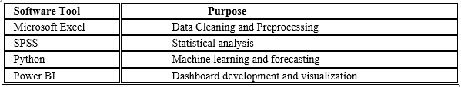
Microsoft Excel was used for data cleaning and preparation activities. SPSS was used to perform statistical analyses including descriptive statistics, correlation analysis, regression analysis, and ANOVA. Python was utilized for machine learning model development and productivity prediction analysis. Power BI was used to create interactive dashboards for visualizing productivity-related insights.

3.4 Statistical Methods
Several statistical techniques were applied to analyze workforce productivity and identify factors affecting operational performance.
Descriptive Statistics - Descriptive statistics were used to summarize the characteristics of the dataset. Measures such as mean, standard deviation, minimum value, and maximum value were calculated to understand the distribution of key variables.
Correlation Analysis - Pearson correlation analysis was conducted to examine relationships between workforce productivity and operational factors such as overtime, incentives, idle time, and workforce size.
Regression Analysis - Multiple linear regression analysis was performed to identify the factors significantly influencing actual productivity. Actual productivity was considered the dependent variable, while overtime, incentives, idle time, and workforce size were treated as independent variables.
Analysis of Variance (ANOVA) - ANOVA was applied to compare actual productivity levels across different working days. This method helped determine whether statistically significant productivity differences existed among working days. This method helped determine whether statistically significant differences existed among groups.

3.5 Machine Learning Methods
Machine learning techniques were employed to predict workforce productivity and identify important factors influencing performance.
Random Forest - The Random Forest algorithm was used as a predictive model to estimate actual productivity based on operational variables. The model was selected due to its ability to handle complex relationships and provide reliable prediction accuracy.
The study focused on the Random Forest model due to its strong predictive performance and ability to identify important productivity factors.

3.6 Productivity Prediction and Optimization Approach
The machine learning results were used to identify important productivity factors and develop productivity improvement strategies. The Random Forest model was applied to predict actual productivity using key operational variables such as targeted productivity, overtime, incentives, idle time, and workforce size. The analysis identified the most important factors affecting productivity and provided recommendations to improve workforce efficiency and operational performance. The findings support effective planning and data-driven decision-making within manufacturing environments.

4.EXPLORATORY DATA ANALYSIS(EDA)
Exploratory Data Analysis (EDA) is an important step in the data analysis process. It helps researchers understand the characteristics of the dataset, identify patterns and trends, detect anomalies, and gain initial insights before applying advanced statistical and predictive techniques.
In this study, EDA was conducted using Microsoft Excel, SPSS, and Python. Various visualizations and summary statistics were used to explore workforce productivity and operational factors within the apparel manufacturing environment.

4.1 Department-wise Productivity Analysis
The average actual productivity was analyzed across different departments.
A bar chart was used to compare departmental productivity performance.

Figure 5: Average Productivity by Department
Interpretation - The analysis indicates that productivity levels vary across departments. The sewing department recorded a higher average productivity compared to the finishing department. This suggests that operational conditions, workload distribution, and workforce performance may differ among departments.
Understanding these differences is important for identifying areas that require productivity improvement and resource optimization.

4.2 Productivity Analysis by Working Day

Figure 6: Average Actual Productivity and Targeted Productivity by Working Day
Interpretation - Productivity was analyzed across different working days to identify daily performance patterns. The results indicate fluctuations in productivity throughout the week. Certain days recorded higher productivity levels, while others showed relatively lower performance. These variations may be associated with workload scheduling, employee attendance, and operational factors.

4.3 Overtime Analysis by Department

Figure 7: Total Overtime by Department
Interpretation - The total overtime hours were compared among departments. The analysis shows that overtime utilization differs across operational units. Departments with higher overtime levels may experience greater production pressure and workload demands. Although overtime can increase output in the short term, excessive overtime may negatively affect employee well-being and long-term productivity.

4.4 Incentive Analysis by Department

Figure 8: Average Incentive by Department
Interpretation - Average incentive payments were examined across departments to understand motivational differences within the workforce. The findings indicate that incentive levels vary among departments. Higher incentive allocations may encourage improved employee performance and productivity. However, incentives should be evaluated alongside other operational factors when assessing productivity outcomes.

4.5 Idle Time Analysis by Department

Figure 9: Average Idle Time by Department
Interpretation - Idle time was analyzed to assess operational efficiency within departments. The results show differences in idle time levels among departments. Higher idle time may indicate operational disruptions, inefficient resource utilization, or workflow bottlenecks. Reducing idle time can contribute to improved workforce productivity and overall manufacturing performance.

5.STATISTICAL ANALYSIS

5.1 Descriptive Statistics
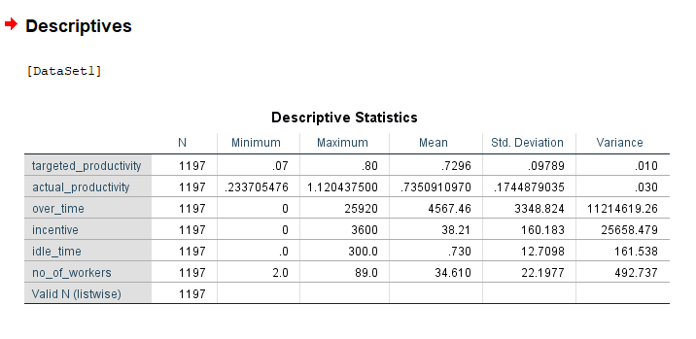

Table 2: Descriptive Statistics
Interpretation - The descriptive statistics show that the dataset contains 1,197 observations. The average actual productivity (0.7351) was slightly higher than the average targeted productivity (0.7296), indicating that workers generally achieved the expected productivity levels. However, the higher standard deviation of actual productivity suggests variations in workforce performance across observations.
The results also show considerable differences in overtime, incentives, idle time, and workforce size. Overtime and incentive values varied significantly among workers and teams, while some observations experienced periods of inactivity due to idle time. Overall, these variations suggest that operational and workforce-related factors may influence productivity within the apparel manufacturing environment.

5.2 Correlation Analysis
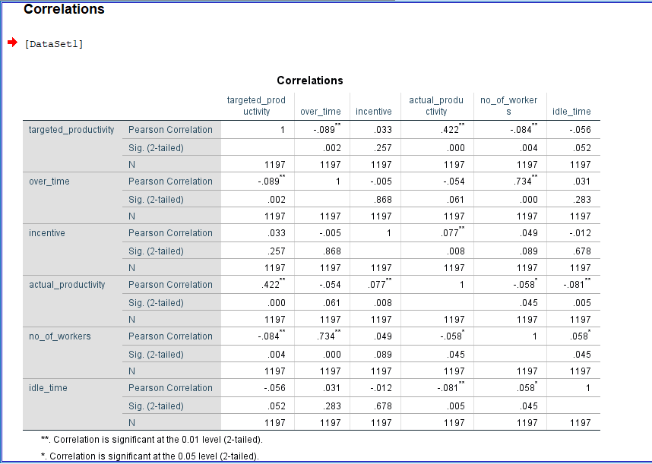

Table 3: Correlation Matrix
Interpretation - The correlation analysis showed that targeted productivity has the strongest positive relationship with actual productivity (r = 0.422), indicating that higher productivity targets are generally associated with higher actual productivity levels. Incentives also showed a weak positive relationship with actual productivity (r = 0.077), suggesting that incentives may slightly improve workforce performance.
In contrast, idle time (r = -0.081) and number of workers (r = -0.058) showed weak negative relationships with actual productivity, indicating that increases in these factors may slightly reduce productivity. The relationship between overtime and actual productivity was weak and not statistically significant (r = -0.054), suggesting that overtime does not have a direct impact on productivity in this dataset.
Overall, the results indicate that targeted productivity is the most influential factor associated with actual productivity, while incentives, idle time, and workforce size have relatively weaker relationships. Further analysis using regression techniques is required to identify the most significant predictors of workforce productivity.

5.3 Regression Analysis
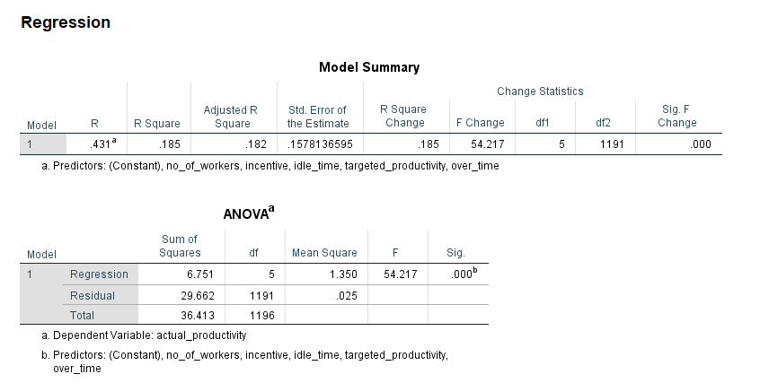

Table 4: Model Summary & ANOVA Table for Regression Model
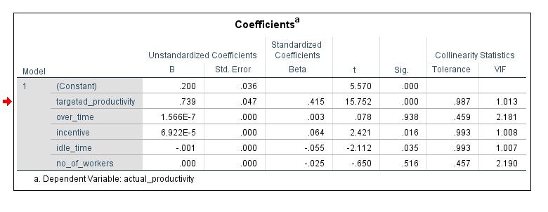

Table 5: Regression Coefficients
Interpretation - The regression analysis showed that the overall model is statistically significant (F = 54.217, p < 0.001) and explains approximately 18.5% of the variation in actual productivity (R² = 0.185). This indicates that the selected variables have a meaningful influence on workforce productivity.
Among the independent variables, targeted productivity was identified as the strongest positive predictor of actual productivity (β = 0.415, p < 0.001). In addition, incentives had a significant positive effect on productivity (β = 0.064, p = 0.016), suggesting that employee incentives can contribute to improved performance. Conversely, idle time showed a significant negative effect on productivity (β = -0.055, p = 0.035), indicating that increased idle time reduces workforce efficiency.
However, overtime (p = 0.938) and number of workers (p = 0.516) were not found to be statistically significant factors affecting actual productivity. Overall, the findings suggest that targeted productivity, incentives, and idle time are the most important factors influencing workforce productivity within the apparel manufacturing environment.

5.4 ANOVA
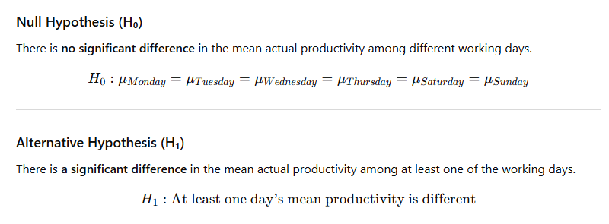
A One-Way ANOVA test was conducted to determine whether there are significant differences in actual productivity across different working days.

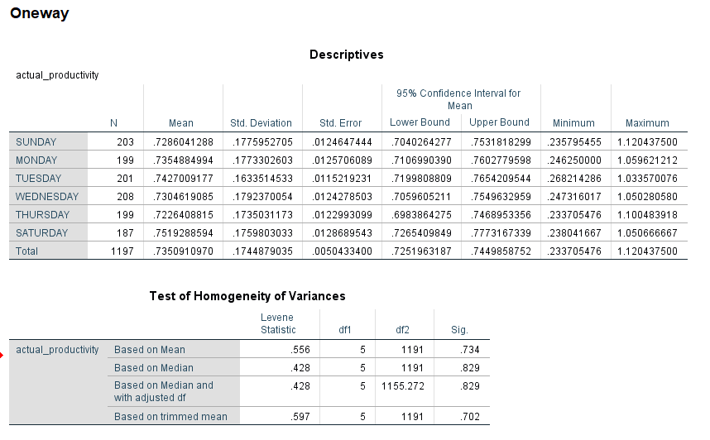

Table 6: Descriptive Statistics by Working Day & Test of Homogeneity of Variances
Test of Homogeneity of Variances - Before conducting the ANOVA test, Levene's Test was performed to assess the assumption of homogeneity of variances.
The results showed a significance value of 0.734, which is greater than 0.05. Therefore, the assumption of equal variances was satisfied, and the ANOVA test could be conducted.
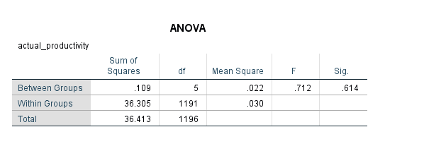

Table 7: One-Way ANOVA Results

The ANOVA results produced an F-value of 0.712 with a significance value (p-value) of 0.614.
p-value = 0.614 > 0.05
The null hypothesis cannot be rejected.

Interpretation - The findings indicate that there is no statistically significant difference in the mean actual productivity across different working days. Although the descriptive statistics show slight variations in productivity levels among Sunday, Monday, Tuesday, Wednesday, Thursday, and Saturday, these differences are not statistically significant.
For example, Saturday recorded the highest average productivity (Mean = 0.752), while Thursday recorded the lowest average productivity (Mean = 0.723). However, the observed differences are relatively small and may have occurred due to random variation rather than actual differences in workforce performance.
Therefore, based on the ANOVA results, it can be concluded that the working day does not significantly influence actual productivity within the apparel manufacturing dataset used in this study.

6.MACHINE LEARNING & PRODUCTIVITY OPTIMIZATION

6.1 Productivity Prediction Model
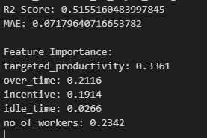
Interpretation –The Random Forest model was developed to predict workforce productivity using operational variables such as targeted productivity, overtime, incentives, idle time, and number of workers. The model achieved an R² Score of 0.5155, indicating that approximately 51.55% of the variation in actual productivity can be explained by the selected variables. The Mean Absolute Error (MAE) of 0.0718 suggests that the prediction errors are relatively low.
Figure 10: Random Forest Model Performance Results
These results indicate that the model has a satisfactory level of predictive performance and can be used to support productivity analysis and workforce planning within the apparel manufacturing environment. The findings support the study objective of developing a data-driven approach for productivity prediction and operational decision-making.
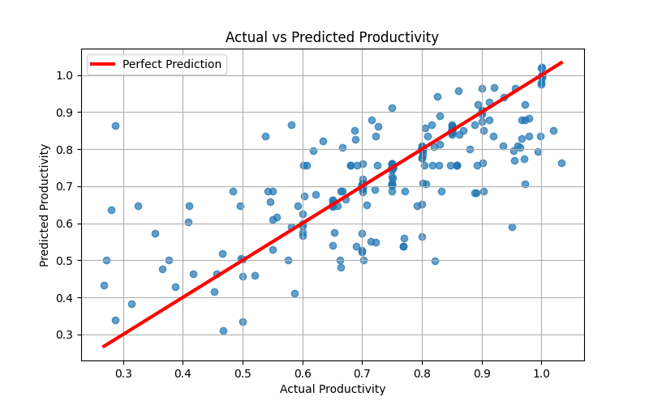
Interpretation – This illustrates the relationship between actual productivity and the productivity values predicted by the Random Forest model. The red line represents the perfect prediction line, where predicted productivity is equal to actual productivity.
Most observations are located relatively close to the red line, indicating that the model produces reasonably accurate productivity predictions. Although some deviations are observed, the overall pattern demonstrates a positive relationship between actual and predicted productivity.
Figure 11: Actual vs Predicted Productivity
These findings suggest that the machine learning model can effectively estimate workforce productivity and provide useful insights for productivity monitoring and performance evaluation. This supports the project objective of utilizing predictive analytics to improve productivity management in the apparel manufacturing industry.

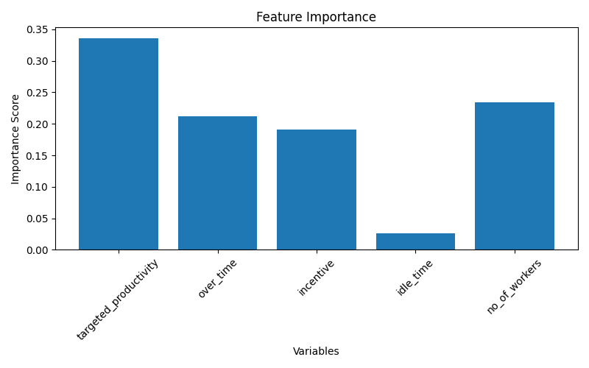

Figure 12: Feature Importance of Workforce Productivity Factors
Interpretation - The Feature Importance analysis was conducted to identify the variables that contribute most significantly to workforce productivity prediction. The results indicate that targeted productivity (0.3361) is the most influential factor affecting actual productivity, followed by number of workers (0.2342), overtime (0.2116), and incentives (0.1914). Idle time (0.0266) was found to have the lowest contribution to the prediction model.
The findings suggest that setting appropriate productivity targets and effectively managing workforce allocation are critical for improving productivity performance. In addition, overtime management and incentive programs also contribute to productivity improvement. These results directly support the study objective of identifying the key factors affecting workforce productivity and operational efficiency within the apparel manufacturing environment.
The machine learning analysis demonstrated that workforce productivity can be predicted with a reasonable level of accuracy using operational variables. The Random Forest model achieved satisfactory predictive performance, while the feature importance analysis identified targeted productivity, workforce size, overtime, and incentives as the most important factors influencing productivity. These findings provide valuable insights for data-driven decision-making and support productivity optimization in apparel manufacturing organizations.

6.2 Productivity Optimization Scenario Analysis
Scenario analysis was conducted to evaluate how changes in key operational variables may influence workforce productivity. Based on the machine learning results, the most important factors affecting productivity were identified and several productivity improvement scenarios were examined.

Scenario 1: Increase Targeted Productivity
The feature importance analysis identified targeted productivity as the most influential factor affecting actual productivity. Therefore, improving productivity targets and performance management practices may contribute to higher workforce productivity.

Scenario 2: Optimize Workforce Allocation
The number of workers was identified as the second most important factor in the prediction model. Effective workforce allocation can improve operational efficiency and productivity performance.

Scenario 3: Improve Overtime Management
Overtime showed a considerable contribution to productivity prediction. Proper overtime planning can help balance production requirements and employee workload while maintaining productivity levels.

Scenario 4: Enhance Incentive Programs
The machine learning model indicated that incentives contribute positively to workforce productivity. Improving incentive schemes may increase employee motivation and operational performance.

Scenario 5: Reduce Idle Time
Although idle time had a lower contribution compared to other variables, reducing unnecessary idle time can improve overall operational efficiency and productivity.

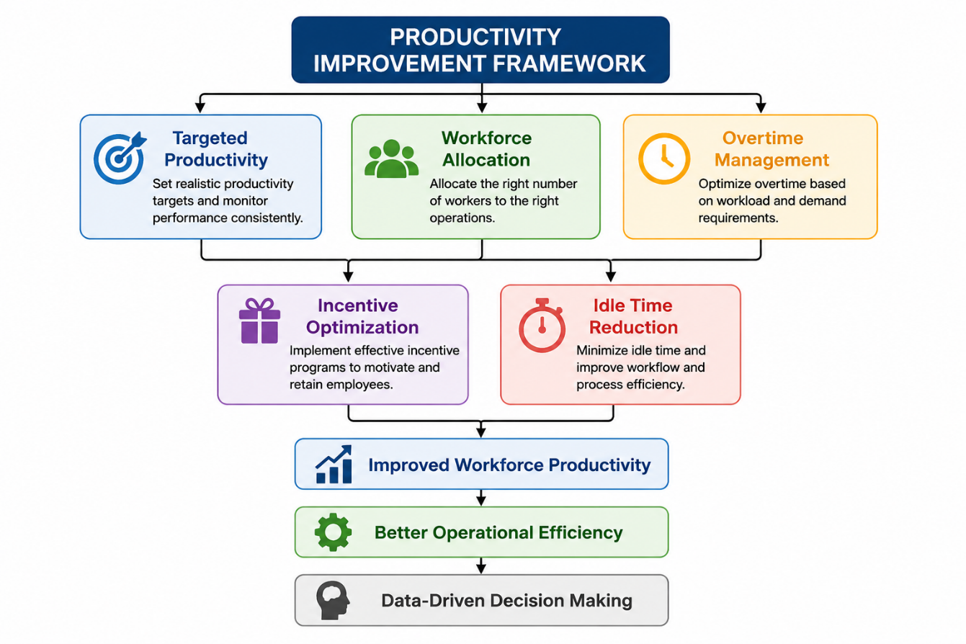
Figure 13: Productivity Optimization Framework

Interpretation - The productivity improvement framework illustrates the key operational factors influencing workforce productivity. Based on the machine learning analysis, targeted productivity, workforce allocation, overtime management, incentive optimization, and idle time reduction were identified as important areas for improving productivity. By effectively managing these factors, organizations can enhance workforce performance, improve operational efficiency, and support data-driven decision-making.

7.POWER BI DASHBOARD

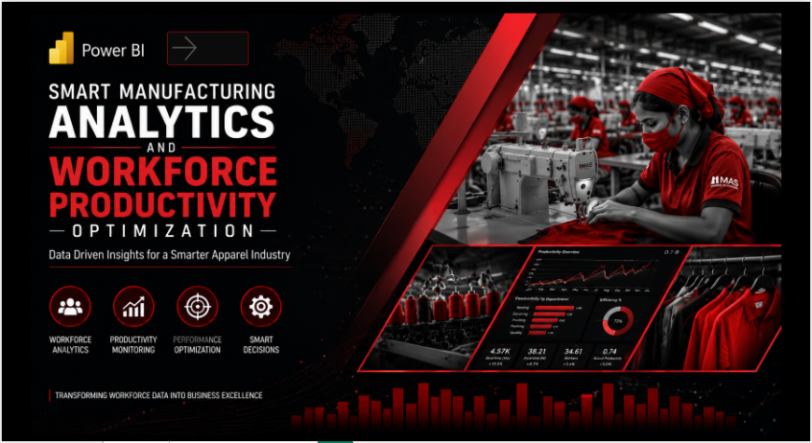
Interpretation - The Workforce Productivity Analytics Dashboard provides an interactive overview of workforce performance and productivity within the apparel manufacturing environment. The dashboard displays key performance indicators (KPIs) such as Actual Productivity (0.74), Targeted Productivity (0.73), Overtime (4.57K), Number of Workers (34.61), and Incentive (38.21), enabling managers to quickly assess overall operational performance.
Figure 14: Workforce Productivity Analytics Dashboard Home Page
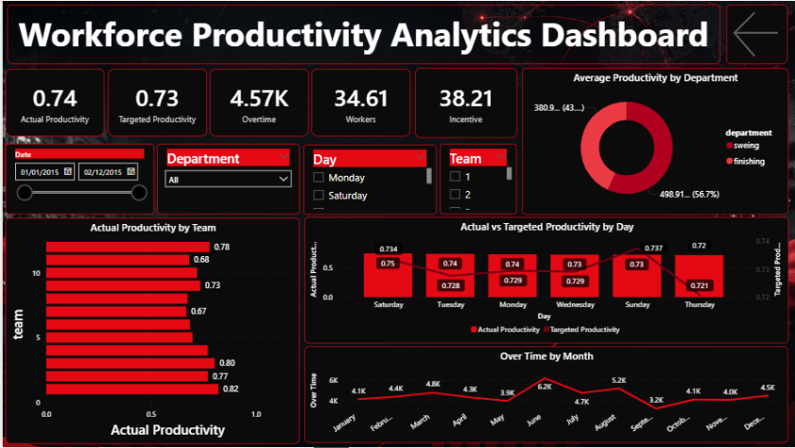
The dashboard also includes visualizations that compare productivity across departments, teams, and working days. The department-wise analysis shows that the sewing department contributes a higher share of productivity compared to the finishing department. Team-level analysis highlights differences in productivity among production teams, allowing managers to identify high-performing and low-performing teams.
In addition, the comparison between actual productivity and targeted productivity indicates that workforce performance generally remains close to the expected productivity levels. The overtime trend analysis provides insights into overtime patterns throughout the year, supporting workforce planning and resource allocation decisions.
Figure 15: Workforce Productivity Analytics Dashboard
Overall, the dashboard serves as a useful business intelligence tool for monitoring workforce productivity, identifying performance trends, and supporting data-driven decision-making in apparel manufacturing operations.

8.FINDINGS AND RECOMMENDATIONS

8.1 Findings
Based on the statistical analysis, machine learning analysis, and Power BI dashboard, several important findings were identified regarding workforce productivity within the apparel manufacturing environment.
Finding 1: Actual Productivity Exceeded Targeted Productivity
The descriptive statistics revealed that the average actual productivity (0.7351) was slightly higher than the average targeted productivity (0.7296). This indicates that workers generally achieved the expected productivity levels.
Finding 2: Targeted Productivity is the Most Important Factor
The correlation and regression analyses identified targeted productivity as the strongest predictor of actual productivity. A moderate positive relationship was observed between targeted productivity and actual productivity (r = 0.422), indicating that higher productivity targets are associated with higher workforce performance.
Finding 3: Incentives Positively Influence Productivity
Both correlation and regression results showed that incentives have a positive impact on actual productivity. Employees receiving higher incentives tend to achieve slightly better productivity levels.
Finding 4: Idle Time Negatively Affects Productivity
The results indicated that idle time has a negative relationship with actual productivity. Increased periods of inactivity reduce workforce efficiency and overall operational performance.
Finding 5: Overtime Does Not Significantly Affect Productivity
The analysis found that overtime has no statistically significant impact on actual productivity. This suggests that increasing overtime alone may not necessarily improve workforce performance.
Finding 6: Productivity Remains Consistent Across Working Days
The One-Way ANOVA results showed no significant differences in actual productivity among different working days (p = 0.614 > 0.05). Therefore, workforce productivity remains relatively stable throughout the week.
Finding 7: Departmental Productivity Differences Exist
The dashboard analysis indicated that the sewing department recorded higher productivity levels compared to the finishing department, suggesting differences in operational efficiency among departments.
Finding 8: Machine Learning Supports Productivity Prediction
The machine learning model demonstrated the ability to predict workforce productivity using operational variables, highlighting the potential of predictive analytics in manufacturing environments.

Finding 9: Business Intelligence Dashboards Improve Monitoring
The Power BI dashboard provided an effective platform for monitoring productivity, workforce performance, overtime trends, and operational indicators, supporting data-driven managerial decisions.

8.2 Recommendations
Based on the findings of this study, the following recommendations are proposed to improve workforce productivity and operational efficiency within apparel manufacturing organizations.
Recommendation 1: Set Realistic Productivity Targets
Since targeted productivity was identified as the strongest predictor of actual productivity, management should establish realistic and achievable productivity targets that motivate employees while maintaining operational efficiency.
Recommendation 2: Improve Incentive Programs
Organizations should strengthen performance-based incentive systems to encourage employee motivation and improve workforce productivity.
Recommendation 3: Reduce Idle Time
Efforts should be made to minimize idle time through improved production planning, workflow management, machine maintenance, and resource allocation.
Recommendation 4: Focus on Operational Efficiency Rather than Overtime
As overtime was not found to significantly improve productivity, organizations should prioritize operational improvements instead of relying heavily on extended working hours.
Recommendation 5: Monitor Departmental Performance
Regular monitoring of departmental productivity should be conducted to identify performance gaps and implement corrective actions where necessary.
Recommendation 6: Implement Predictive Analytics
Organizations should adopt machine learning and predictive analytics techniques to predict workforce productivity and support workforce planning.
Recommendation 7: Utilize Business Intelligence Dashboards
Interactive dashboards should be integrated into management practices to provide real-time performance monitoring and support informed decision-making.
Recommendation 8: Conduct Continuous Productivity Assessments
Regular productivity assessments should be performed to identify operational challenges and evaluate the effectiveness of improvement strategies.

9.CONCLUSION
This study successfully achieved its main objective of developing a smart analytics framework for analyzing workforce productivity and operational efficiency within the apparel manufacturing industry.
The first objective of analyzing workforce productivity was achieved through descriptive statistics and exploratory data analysis. The results provided a clear understanding of productivity patterns, overtime utilization, incentives, idle time, and workforce distribution within the dataset.
The second and third objectives were achieved through correlation and regression analyses. The findings revealed that targeted productivity, incentives, and idle time significantly influence actual productivity. Targeted productivity was identified as the strongest positive predictor, while idle time showed a negative impact on workforce performance.
The fourth objective of comparing productivity among different groups was achieved using ANOVA analysis. The results indicated that there were no statistically significant differences in actual productivity across different working days.
The fifth objective was achieved through machine learning and productivity optimization scenario analysis. The Random Forest model was used to predict actual productivity, while scenario analysis identified key improvement areas such as targeted productivity, workforce allocation, overtime management, incentive optimization, and idle time reduction.
The final objective was achieved through the development of an interactive Power BI dashboard. The dashboard effectively visualized productivity indicators, departmental performance, team productivity, and overtime trends, supporting data-driven decision-making.
Overall, the study demonstrates how statistical analysis, machine learning models, and business intelligence tools can be integrated to improve workforce productivity analysis in the apparel manufacturing industry. The findings provide valuable insights for managers and decision-makers and highlight the importance of adopting data-driven approaches to enhance operational efficiency and productivity performance.
Future Work
Future studies may incorporate larger and more diverse manufacturing datasets, additional operational variables, and advanced machine learning algorithms to improve prediction accuracy. Furthermore, real-time production data and IoT-based monitoring systems could be integrated to enhance workforce productivity analysis and decision-making processes.

10.REFERENCES

Dataset Source
UCI Machine Learning Repository – Productivity Prediction of Garment Employees Dataset
Chowdhury, A., & Rahman, M. (2020). Productivity prediction of garment employees dataset. UCI Machine Learning Repository. Retrieved from https://archive.ics.uci.edu
Journal Articles
Attaran, M. (2020). Digital technology enablers and their implications for supply chain management. Supply Chain Forum: An International Journal, 21(3), 158–172.
Gunasekaran, A., Subramanian, N., & Ngai, E. W. T. (2019). Quality management in the manufacturing industry: A review and future research directions. International Journal of Production Economics, 207, 1–12.
Kamble, S. S., Gunasekaran, A., & Sharma, R. (2018). Analysis of the driving and dependence power of barriers to adopt industry 4.0 in Indian manufacturing industry. Computers in Industry, 101, 107–119.
Wamba, S. F., Gunasekaran, A., Akter, S., Ren, S. J. F., Dubey, R., & Childe, S. J. (2017). Big data analytics and firm performance: Effects of dynamic capabilities. Journal of Business Research, 70, 356–365.
Statistics and Analytics References
Field, A. (2018). Discovering statistics using IBM SPSS statistics (5th ed.). Sage Publications.
Hair, J. F., Black, W. C., Babin, B. J., & Anderson, R. E. (2019). Multivariate data analysis (8th ed.). Cengage Learning.
Montgomery, D. C., Peck, E. A., & Vining, G. G. (2021). Introduction to linear regression analysis (6th ed.). Wiley.
Machine Learning and Predictive Analytics References
Hyndman, R. J., & Athanasopoulos, G. (2021). Forecasting: Principles and practice (3rd ed.). OTexts. Retrieved from https://otexts.com/fpp3/
Makridakis, S., Wheelwright, S. C., & Hyndman, R. J. (2019). Forecasting Methods and Applications (3rd ed.). Wiley.

Machine Learning References
Géron, A. (2022). Hands-on machine learning with Scikit-Learn, Keras, and TensorFlow (3rd ed.). O'Reilly Media.
James, G., Witten, D., Hastie, T., & Tibshirani, R. (2021). An introduction to statistical learning: With applications in R (2nd ed.). Springer.
Business Intelligence and Power BI References
Russo, M., & Ferrari, A. (2020). Analyzing data with Microsoft Power BI and Power Pivot for Excel. Microsoft Press.
Meyers, Z. (2022). Microsoft Power BI for beginners and analysts. Packt Publishing.
Software References
IBM Corporation. (2023). IBM SPSS Statistics for Windows (Version 29) [Computer software]. IBM Corporation.
Microsoft Corporation. (2024). Microsoft Excel [Computer software]. Microsoft Corporation.
Microsoft Corporation. (2024). Microsoft Power BI Desktop [Computer software]. Microsoft Corporation.
Python Software Foundation. (2024). Python (Version 3.x) [Computer software]. https://www.python.org





